**Launch AI Platform Notebooks**

To launch AI Platform Notebooks:

1. Click on the **Navigation Menu** and navigate to **AI Platform**, then to **Notebooks**.
2. On the Notebook instances page, click **New Instance**. Select the latest version of TensorFlow 2.x *without GPUs*.

In the pop-up, confirm the name of the deep learning VM, move to the bottom of the window, then click **Create**.

The new VM will take 2-3 minutes to start.

1. Click **Open JupyterLab**. A JupyterLab window will open in a new tab.

**Clone the example repo within your AI Platform Notebooks instance**

To clone the training-data-analyst notebook in your JupyterLab instance:

1. In JupyterLab, click the **Terminal** icon to open a new terminal.
2. At the command-line prompt, type in the following command and press Enter.

git clone https://github.com/GoogleCloudPlatform/training-data-analyst

1. Confirm that you have cloned the repository by double clicking on the training-data-analyst directory and ensuring that you can see its contents. The files for all the Jupyter notebook-based labs throughout this course are available in this directory.

Navigate to the example notebook

In AI Platform Notebooks, navigate to training-data-analyst/self-paced-labs/ai-platform-qwikstart and open ai_platform_qwik_start.ipynb.

Clear all the cells in the notebook (look for the Clear button on the notebook toolbar) and then Run the cells one by one.

When prompted, come back to these instructions to check your progress.

**Run your training job in the cloud**

Test Completed Tasks - Step 3.1

Click **Check my progress** to verify your performed task.

Set up a Cloud Storage bucket.

Check my progress

Click **Check my progress** to verify your performed task.

Upload the data files to your Cloud Storage bucket.

Check my progress

Test Completed Task - Step 3.2

Click **Check my progress** to verify your performed task.

Run a single-instance trainer in the cloud.

Check my progress

Test Completed Tasks - Step 3.3

Click **Check my progress** to verify your performed task.

Create an AI Platform model.

Check my progress

Click **Check my progress** to verify your performed task.

Create a version v1 of your model.

Check my progress

**Test your Understanding**

Below are a multiple choice questions to reinforce your understanding of this lab's concepts. Answer them to the best of your abilities.

A model version is an instance of a machine learning solution stored in the AI Platform model service.



True



False

AI Platform offers training jobs and batch prediction jobs.



True



False

**Congratulations!**

In this lab you've learned how to train a [TensorFlow](http://tensorflow.org/) model both locally and on [AI Platform](https://cloud.google.com/ml-engine/docs/), and then how to use your trained model for prediction.

  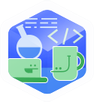  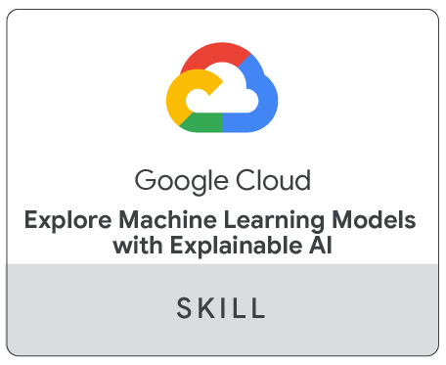

**Finish your quest**

This self-paced lab is part of the Qwiklabs [Machine Learning APIs](https://google.qwiklabs.com/quests/32), [Baseline: Data, ML, AI](https://google.qwiklabs.com/quests/34), [Intro to ML: Language Processing](https://google.qwiklabs.com/quests/82), [Intro to ML: Image Processing](https://google.qwiklabs.com/quests/85) and [Explore Machine Learning Models with Explainable AI](https://google.qwiklabs.com/quests/126) Quests. A Quest is a series of related labs that form a learning path. Completing a Quest earns you a badge to recognize your achievement. You can make your badge (or badges) public and link to them in your online resume or social media account. Enroll in a Quest and get immediate completion credit if you've taken this lab. [See other available Qwiklabs Quests](http://google.qwiklabs.com/catalog).